**EXPERIMENT – 4 & 5**

Exp No 4 and 5: Practicing DDL Commands (Data Definition Language) The data definition language is used to create an object, alter the structure of an object and also drop already created object. The Data Definition Languages used for table definition can be classified into following:

* Create table command
* Alter table command
* Truncate table command
* Drop table command

1.Create table

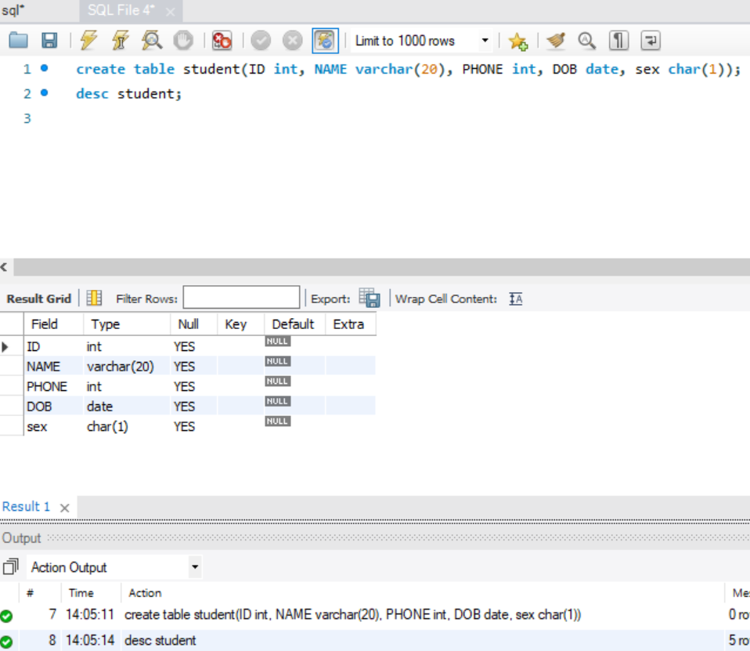

2.Alter table

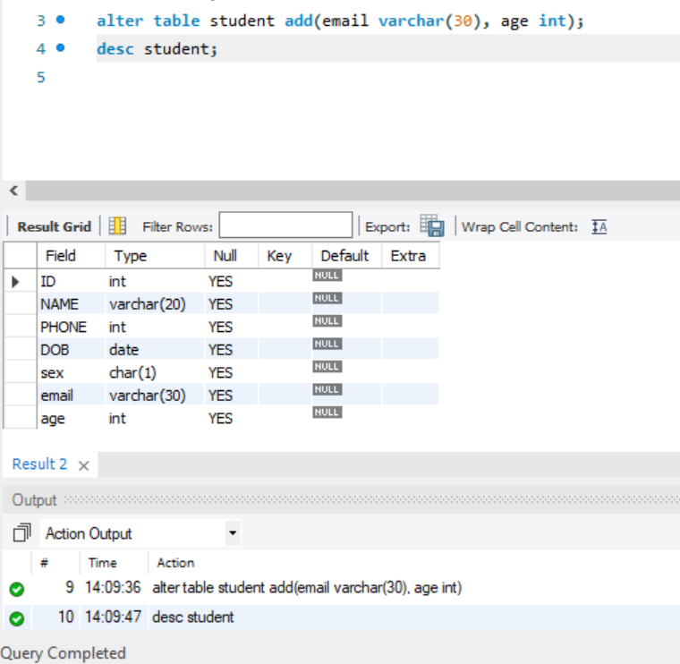

3. Truncate table

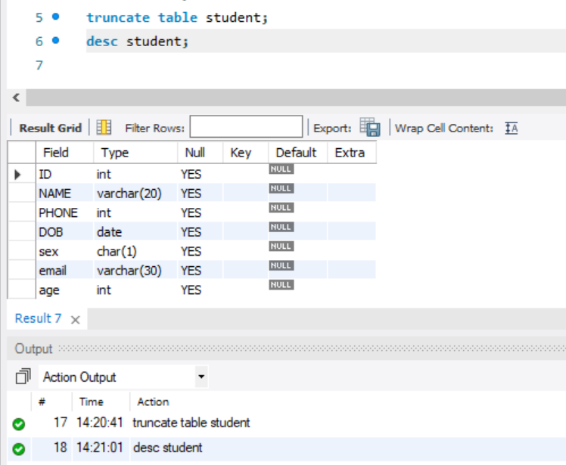

4.Drop table

